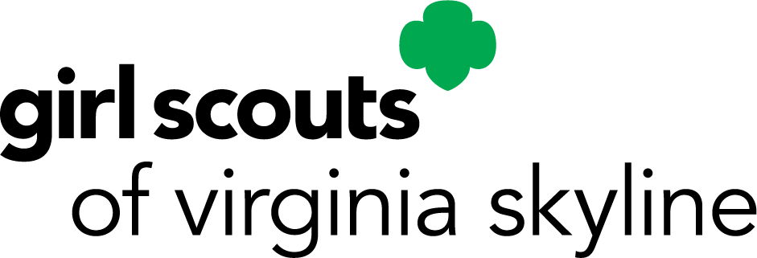TRACY AND THELMA LOYD CONSERVATION AWARD
LETTER OF SUPPORT

Submitted in support of: |  | Date:
Name and complete address of person submitting this reference:
Name:
Address:
City: | State: | Zip:
Day phone number: - - | Evening phone number: - -
E-mail address: | Occupation or Girl Scout position:
I am in support of the nomination because:
How did this project benefit Girl Scouting or the community (city/town/county or non-profit)?
Other pertinent information that may be helpful:
Signature: |  | Date:

When completed, return this to the person who asked for your letter of support or, if so directed

E-mail to: adultrecognitions@gsvsc.org

Deadline is October 31

4057B – R 8/2023(E)

