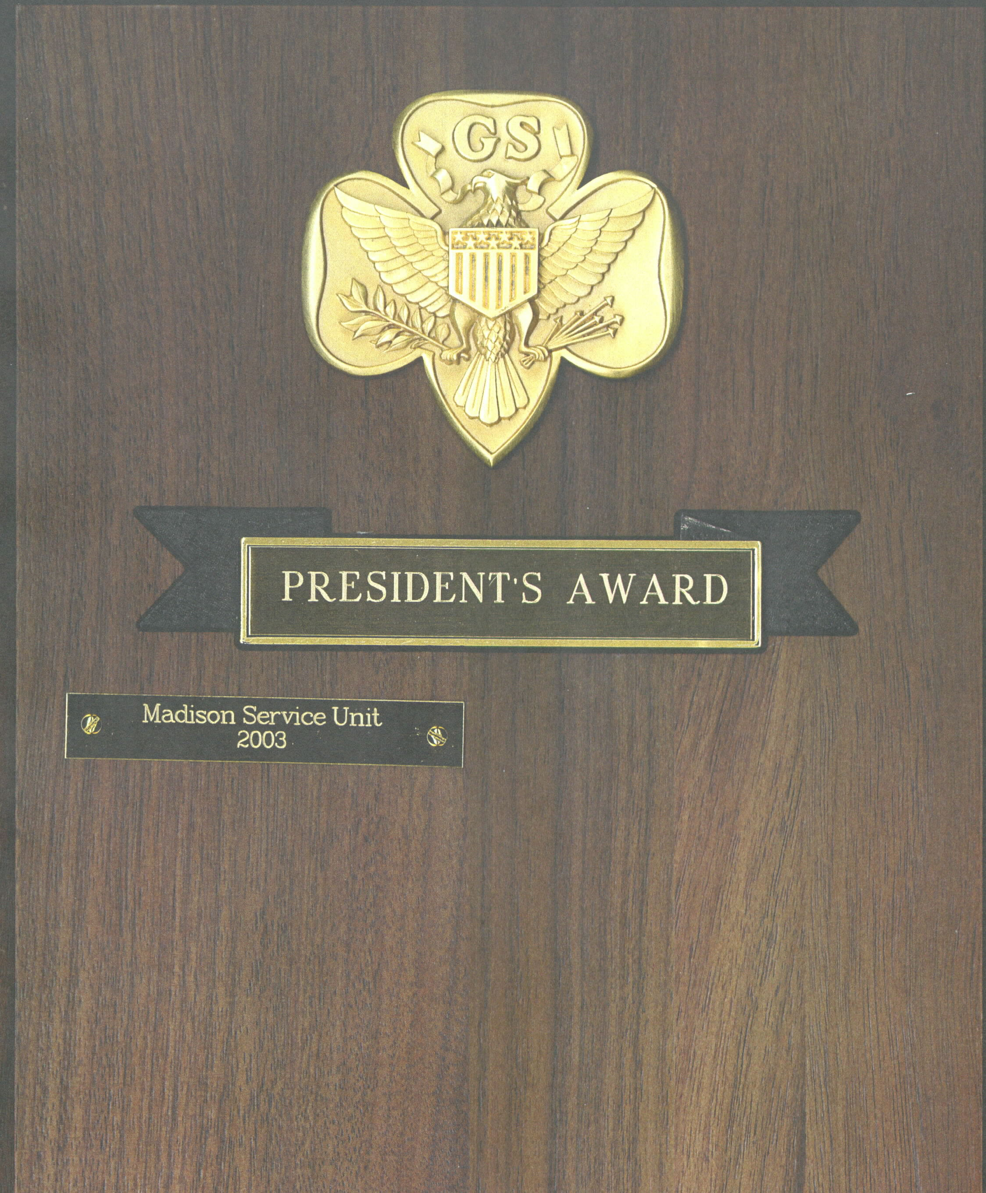GSUSA Adult Award
Nomination for President’s Award

Description:
The President’s Award recognizes the efforts of a service-delivery team or committee whose exemplary service in support of delivering the Girl Scout Leadership Experience surpassed team goals and resulted in significant, measurable impact toward reaching the council’s overall goals.
Criteria:
- All service team members are registered Girl Scouts.
- All service-team members have met all requirements and expectations of the positions held.
- The service-delivery team has significantly contributed to meeting one or more of the council’s mission-delivery goals.
- The service-delivery team reflects the diversity of the target audience or area it serves, in girl and adult membership, in all pathways offered.
- The service-delivery team actively recognizes, understands, and practices the values of inclusive behavior.

Letters of support (Form 4065) are needed from two additional individuals.

Name of person completing nomination form:
Street:
City: | State: | Zip:
E-mail: |  | Phone:
Best time and method to contact you:

 |  | Name of nominated team/committee:
 | Team lead contact information:
 |  | Name:
 |  | Street:
 |  | City: | State: | Zip:
 |  | E-mail: |  | Phone:
 | Are all team members current members of Girl Scouts?
 |  | Yes No Not sure
 | Have all team members completed the requirements for their positions?
 |  | Yes No Not sure
 | Does this team reflect the diversity of the target audience or area it serves, in girl and adult membership, in all pathways offered?
 |  | Yes No Not sure
Please describe how the team has delivered outstanding service that has significantly contributed to surpassing their team goal and meeting one or more of the council’s mission-delivery goals. Also, please describe how this team actively recognized, understood, and practiced the values of inclusive behavior. Attach additional pages, if necessary.

Signature of person submitting nomination:
Date:

Please e-mail to adultrecognitions@gsvsc.org
Can be submitted at any time.

For Office Use Only
Recognition Committee decision:
Approved Denied Date of Recognition Committee meeting:
If pending, please describe the information required:

